Questionnaire

We're creating an Intranet college network as a part of our SEN project, in which you'll be able to connect with anyone on campus via website that runs on Intranet only. The idea here is TO REPLACE WEBMAIL FOR MASS COMMUNICATION as 15 mb of mail storage always overflows. It'll be a fancy single-page web-app with all those HTML5-CSS3 bells & whistles and some design beauty, and we're serious and making it, so help us!

NAME : _______________
DAIICT ID: ____________

Q1. On the Scale of 1 to 5 how much do you think communicating with your batchmates and professor over the social network is useful for you? *
[Note: Rate 1 For Low and Rate 5 For High ]

1 2 3 4 5

Q2. Which of your existing web accounts from the following do you want to associated with the CampusTalk? *

Facebook
LinkedIn
Twitter

Q3. Do you want file sharing facility? *

Yes No

Q4. Chat options should be there or not? *

Yes No

Q5. Should the system can be accessed over the internet outside Campus? *

Yes No

Q6. Allow Professors to see each of the students' activities on the site ? *

Yes No

Q7. Your Suggestion on having yet-another-semi-social-network as CampusTalk ____________________________________________________________________________________________________________________________________________________________________________________________________________________________________

Thank You

Responses From Questionnaire
Total Responses - 52

Q1. On the Scale of 1 to 5 how much do you think communicating with your batchmates and professor over the social network is useful for you? *
[Note: Rate 1 For Low and Rate 5 For High ]



Q2. Which of your existing web accounts from the following do you want to associated with the CampusTalk? *

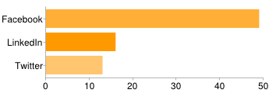

Q3. Do you want file sharing facility? *
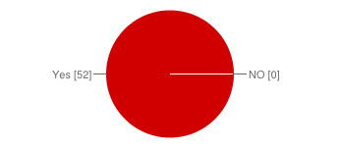

Q4. Chat options should be there or not? *
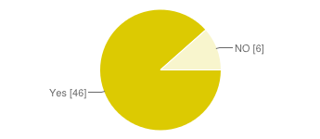

Q5. Should the system can be accessed over the internet outside Campus? *
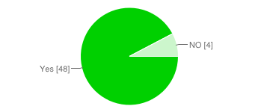

Q6. Allow Professors to see each of the students' activities on the site ? *
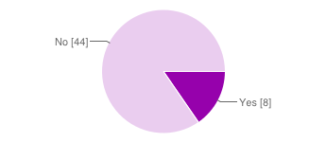

Q7. Following are the Suggestion provided
[Note: Some of the Suggestion From Suervey]

- this app must be access outside from the campus means accessible over the internet. This point is most important. And also include intranet data “daiictpdc” because many of us which are not hostellite.
- More storage than webmail and faster than webmail.
- Some type of modification facility should be maintained about the post user will posting. Etc.

